Retele /25 – Popescu Dragos

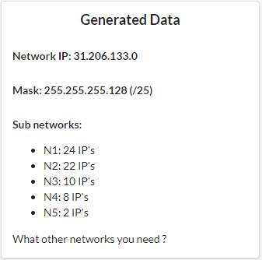

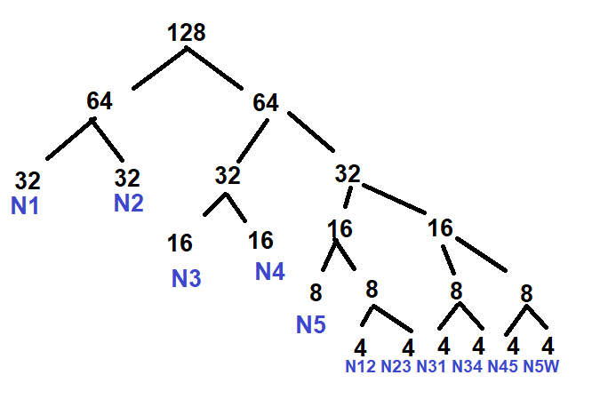N1:24+3=27 (32)

N2:22+3=25 (32)

N3:10+3=13 (16)

N4:8+3=11 (16)

N5:2+3=5 (8)

N12=4

N23=4

N31=4

N34=4

N45=4

N56W=4

N1:31.206.133.0->31.206.133.31 R1: 31.206.133.1 S1: 31.206.133.2

N2: 31.206.133.32->31.206.133.63 R2: 31.206.133.33 S2WEB: 31.206.133.34

N3: 31.206.133.64->31.206.133.79 R3: 31.206.133.65 S3DNS: 31.206.133.66

N4: 31.206.133.80->31.206.133.95 R4: 31.206.133.81

N5: 31.206.133.96->31.206.133.103 R5: 31.206.133.97

N12: 31.206.133.104->31.206.133.107 R1: 31.206.133.105 R2: 31.206.133.106

N23: 31.206.133.108->31.206.133.111 R2: 31.206.133.109 R3: 31.206.133.110

N31: 31.206.133.112->31.206.133.115 R3: 31.206.133.113 R1: 31.206.133.114

N34: 31.206.133.116->31.206.133.119 R3: 31.206.133.117 R4: 31.206.133.118

N45: 31.206.133.120->31.206.133.123 R4: 31.206.133.121 R5: 31.206.133.122

N56W: 31.206.133.124->31.206.133.127 R5: 31.206.133.125 R6W: 31.206.133.126